Mise en œuvre de JDBC

Creation of a database on MS Access, and creation of a table.

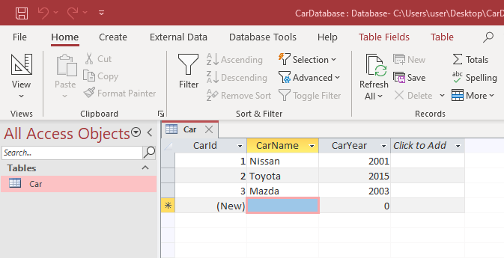

I used UCanAccess as the JDBC Driver to make the connection between my java app and the Access database.



I unzipped the folder then added the jar files to the ClassPath of the project via Intellij IDEA.

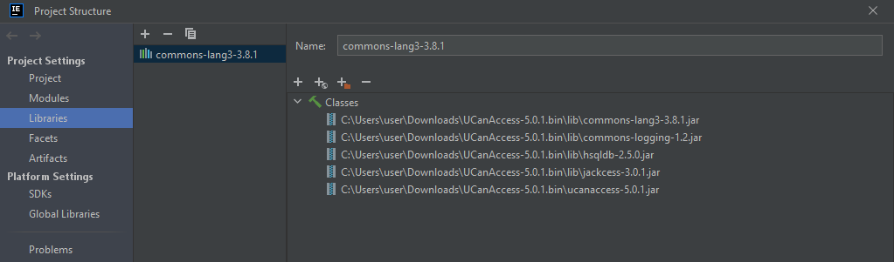

I wrote the code that makes the connection with the database.

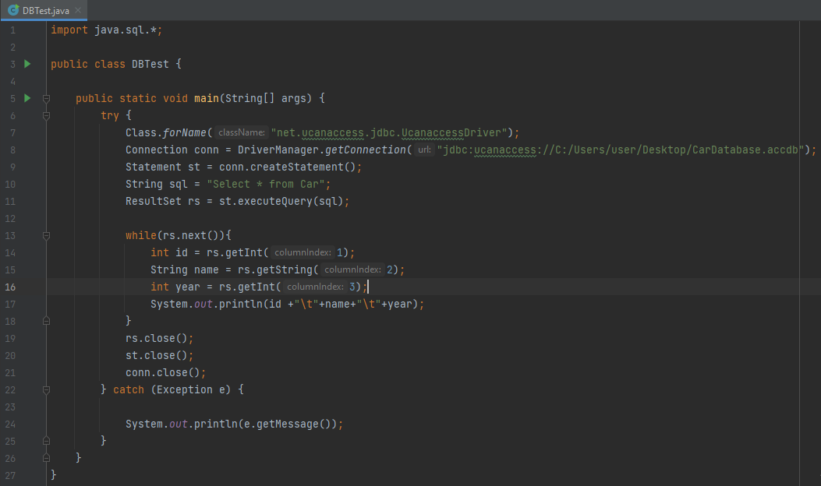

Output of the code:

